**Manage User**

**‘List of all Registered Users’ Page** – This page shows you a detailed list of registered user. Here, you will see the first name, last name, email, address, phone number, user name, password and vet. You also have the option to edit or delete information, see details and enter new details.

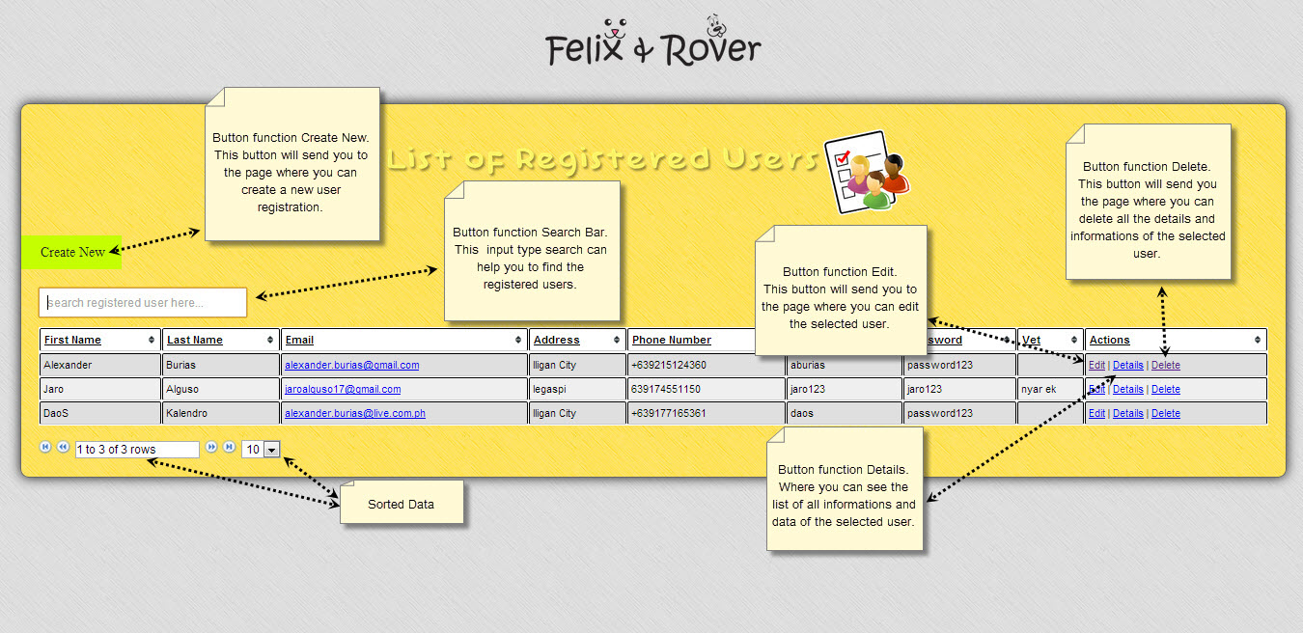

**‘Create New User’ Page** – This page is where you enter type of a new user and also the details of the selected user.

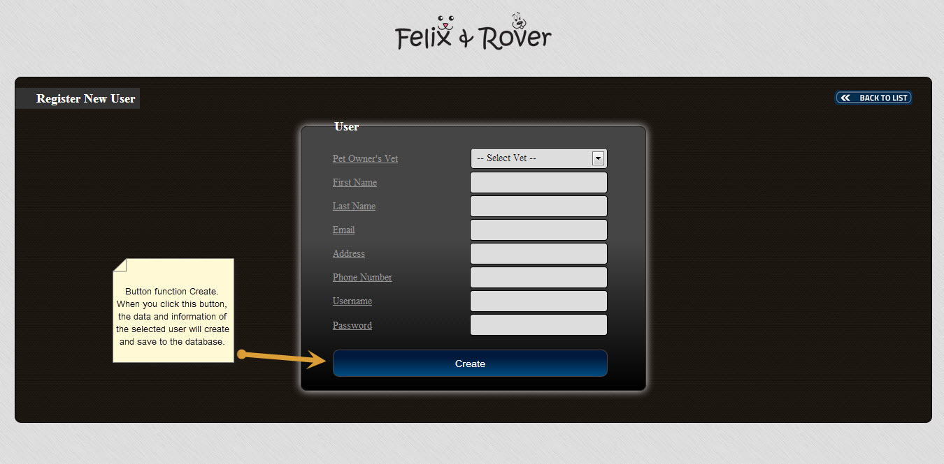

**‘Delete User’ Page-** This page is where you go to if you wish to delete registered user.

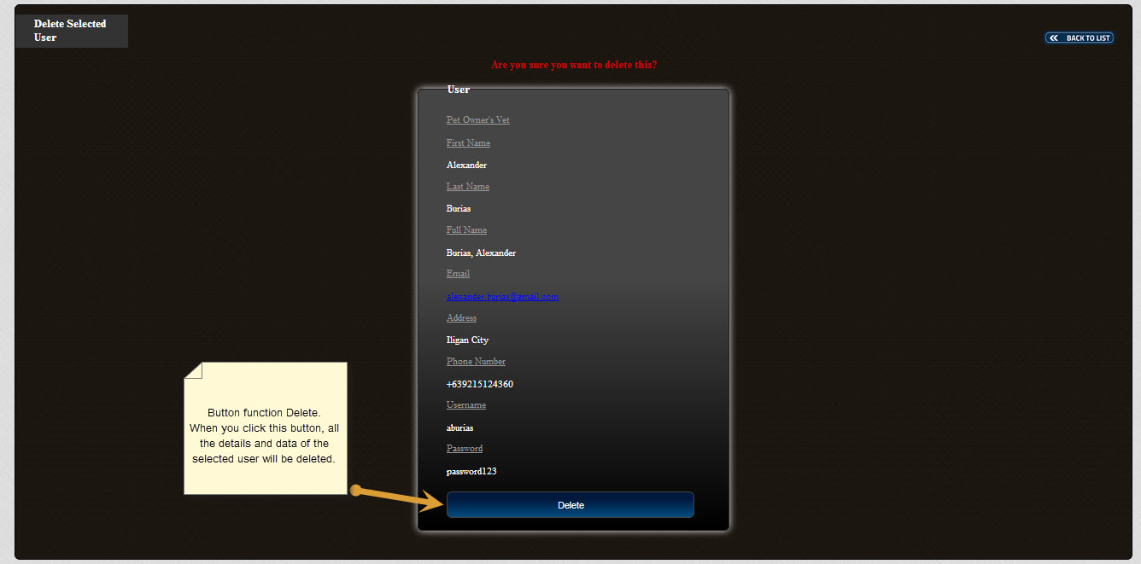

**‘Details of User’ Page** – This page allows you to edit details of the user, such as its first name, last name, email, address, phone number, user name, password and vet.

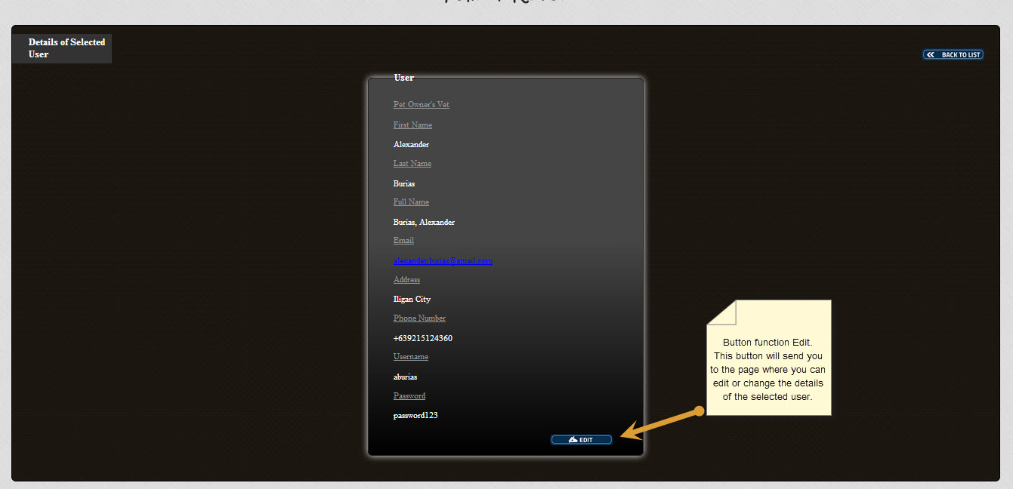

**‘Update Selected User’ Page** – This page is where you can update registered user details if you wish to make changes to its first name, last name, email, address, phone number, user name, password and vet.

